People of Labor: Honored Veterinarian of Tatarstan from Zelenodolsk District - a worthy example for young specialists
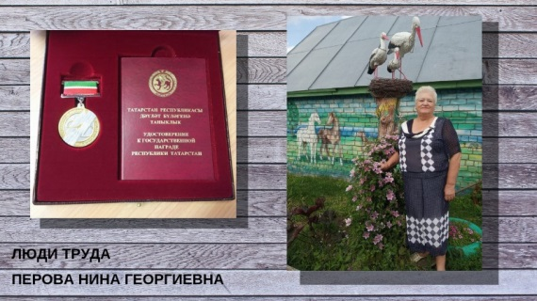
“A doctor treats a person, and a veterinarian treats humanity” - these words of Academician Ivan Pavlov have become a popular expression for good reason. The veterinarian is one of the most noble, humane professions in which there are no random people. A worthy example for young professionals is the hero of our column “People of Labor” Nina Georgievna Perova, who works as a veterinarian in Zelenodolsky district.
The Ministry of Agriculture and Food of the Republic of Tatarstan writes about real workers who deserve honor and respect with their daily work, dedication, rich experience and high professionalism.
Nina Perova was born on January 1, 1952 in the village of Kulaevo in the Pestrechinsky district of the TASSR. When young Nina was 22 years old, she received a diploma with honors from the Veterinary University named by Bauman and decided to stay working within the walls of the educational institution, becoming a junior researcher. Three years later, Nina Perova became the chief veterinarian of the Kazan poultry farm and worked there for 30 years.
Today, Nina Perova works at the Zelenodolsk Regional State Veterinary Association State Budgetary Institution and, due to her responsible attitude and hard work, she is respected among the staff of the enterprise, as well as among managers and employees of agricultural enterprises.
Nina Perova is devoted to her profession. Her most important qualities, according to colleagues, are the ability to find a common language with any person to solve the problem and good organizational skills.
Nina Perova always keeps up to date and constantly improves her professional level and uses advanced techniques in her work. In 2018, she successfully graduated from continuing education courses in the areas of “Training to work in the subsystems“ Mercury GVE ”and“ Mercury HS ”FSIS“ Mercury ”. During the same year, she passed certification of veterinary and sanitary inspectors and arthritic experts. Nina Perova shares her valuable experience with young specialists and serves as a worthy example for them.
In 1989, she was awarded a silver medal for her achievements in the development of the USSR National Economy. In 2001 she received the title of Honored Veterinarian of the Republic of Tatarstan.

